Programming Exercise 5:
In the following exercise we ask you to, write a robot program, with which the best position of the manipulator base in the robot scene can be determined in order to reach the parts in the scene. To start use the provided zip file (ReachabilityAnalysis.zip), containing the definition of the work cell and a skeleton program. You can choose if you want to use the Python or the C++ skeleton.
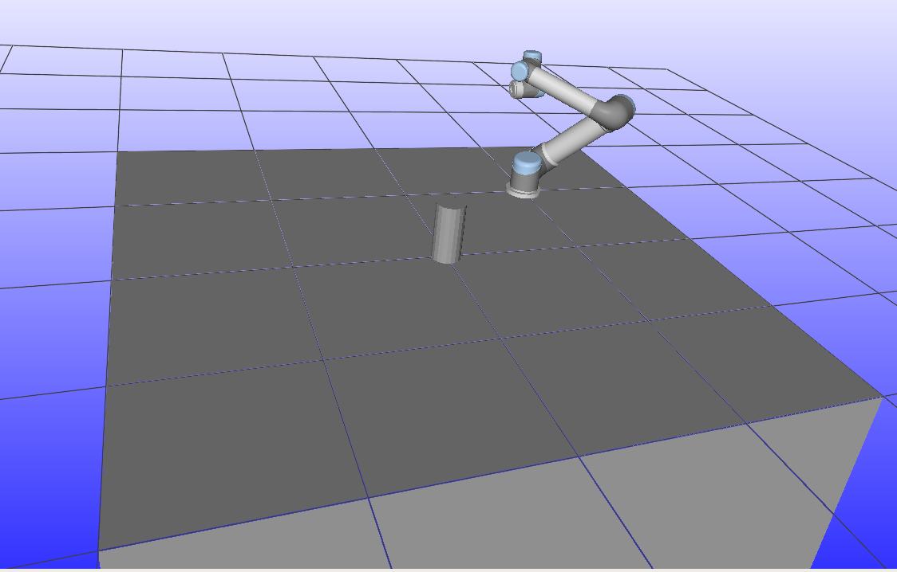
Figure 1 Test scene
Load the scene in RW and build the program. The challenge is to test the reachability of the manipulator. The manipulator should perform a 360° (rollAngle = 360) circle according to the TCP frame around the cylinder placed in the scene, with as many collisions free kinematical solutions as possible. Changing the position of the base, will change the number of solutions.
Use the following function to detect the collisions between the links of the robot:
- rw::proximity::CollisionDetector::Ptr

To calculate the inverse kinematics, use the closed loop IK solver from RW. It always gives only one solution for the current robot configuration.

- rw::invkin::ClosedFormIKSolverUR::Ptr

To play back and visualize the solutions, use the RW playback plug-in. In order to work, you have to write a .rwplay file and load it in RW. The function for writing the file is in the skeleton.cpp file.

Requirement:
Test at least 10 different positions of the robot base and evaluate the number of IK collision free solution. Based on the results pick the best position.

